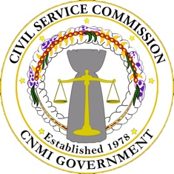
COMMONWEALTH OF THE NORTHERN MARIANA ISLANDS
CIVIL SERVICE COMMISSION
OFFICE OF PERSONNEL MANAGEMENT
P.O. BOX 5153 CHRB, SAIPAN, MP 96950-5153
CSC TEL NO: (670) 233-1606 | FAX NO: (670) 233-4096
OPM TEL. NO: (670) 234-6925 / 6958 / 8036 | FAX NO. (670) 234-1013
CATALINA L. TEBIT CSC website: http://www.cnmicsc.net | OPM website: http://www.cnmiopm.net ISIDRO K. SEMAN
Acting Chairperson, CSC Director of Personnel

PUBLIC NOTICE
Pursuant to 1 CMC §8113, the Civil Service Commission hereby gives notice that the Board will meet on March 1, 2019 for a Special Meeting at 9:30 a.m. The meeting will be held at the Civil Service Commission Conference Room, Springs Plaza Middle Rd. Gualo Rai, Saipan. The agenda for the meeting is as follows:

AGENDA
- Preliminaries
  - Call Meeting to Order
  - Roll Call
  - Review and Adoption of Agenda
  - Review and Adoption of Minutes
i. February 11, 2019 – Special Meeting

- Public Comments

- Reports
  - Chairperson
  - Director
  - Executive Assistant
  - Committee

- Communications

- Old Business
a. New Classification Specification
i. Financial Aid Officer
b. Existing Classification Specification
i. Compliance Officer

- New Business

- Executive Session
- At anytime throughout the scheduled meeting of the Civil Service Commission, the Commission may be required to enter into an Executive Session to discuss matters deemed privileged and confidential.

- Miscellaneous/Announcement

- Adjournment

